Standard 1 Practice Problems

- State the error made in the following distribution. Then complete the distribution correctly.
−4(ξ + 2) = −4ξ + 2

- Solve the following equation and state the properties you used in each step.
3( x − 2) − ( x + 5) = −22

- Name the property illustrated in each statement, then find the missing number that makes it correct:

  - −3+(5+1.5)=(−3+____)+1.5

  - 1/8 ⋅ 7 = 7⋅_____
4. Name the property illustrated in each statement:

A. 9⋅1/9 = 1

B. 8 + 0 = 8

C. 6(4+x)=24+6x

- Prove or give a counterexample: x + x =x² for all real numbers x.

- The sum of three consecutive even integers is –66. Find the three integers.
Standard 2 Practice Problems

7.

8.
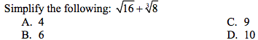

9.

10.
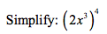

11.
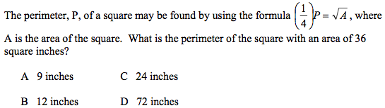

12a.Write a number

b. Write the opposite of that number

c. Write the reciprocal of that number

